**Descriptive Statistics Summary (First Week)**

**Variable Types**

We have covered a lot up to this point! We started with identifying data types as either categorical or quantitative. We then learned we could identify quantitative variables as either continuous or discrete. We also found we could identify categorical variables as either ordinal or nominal.

**Categorical Variables**

When analyzing categorical variables, we commonly just look at the count or percent of a group that falls into each **level** of a category. For example, if we had two **levels** of a dog category: lab and not lab. We might say, 32% of the dogs were lab (percent), or we might say 32 of the 100 dogs I saw were labs (count).

However, the 4 aspects associated with describing quantitative variables are not used to describe categorical variables.

**Quantitative Variables**

Then we learned there are four main aspects used to describe quantitative variables:

1. Measures of **Center**
2. Measures of **Spread**
3. **Shape** of the Distribution
4. **Outliers**

**Measures of Center**

We looked at calculating measures of Center

1. **Means**
2. **Medians**
3. **Modes**

**Measures of Spread**

We also looked at calculating measures of Spread

1. **Range**
2. **Interquartile Range**
3. **Standard Deviation**
4. **Variance**

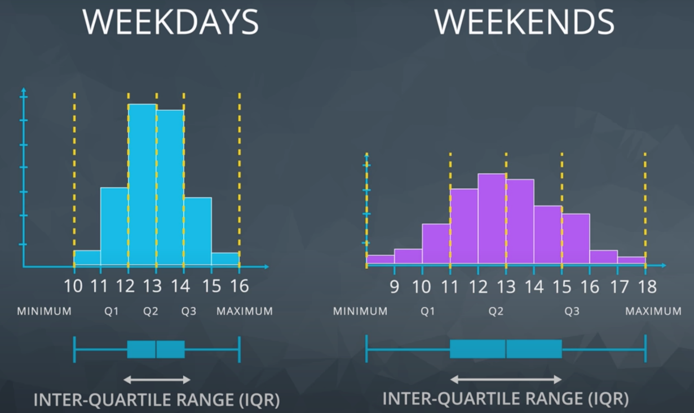

How to make box plot

**Shape**

We learned that the distribution of our data is frequently associated with one of the three **shapes**:

**1. Right-skewed**

**2. Left-skewed**

**3. Symmetric** (frequently normally distributed)

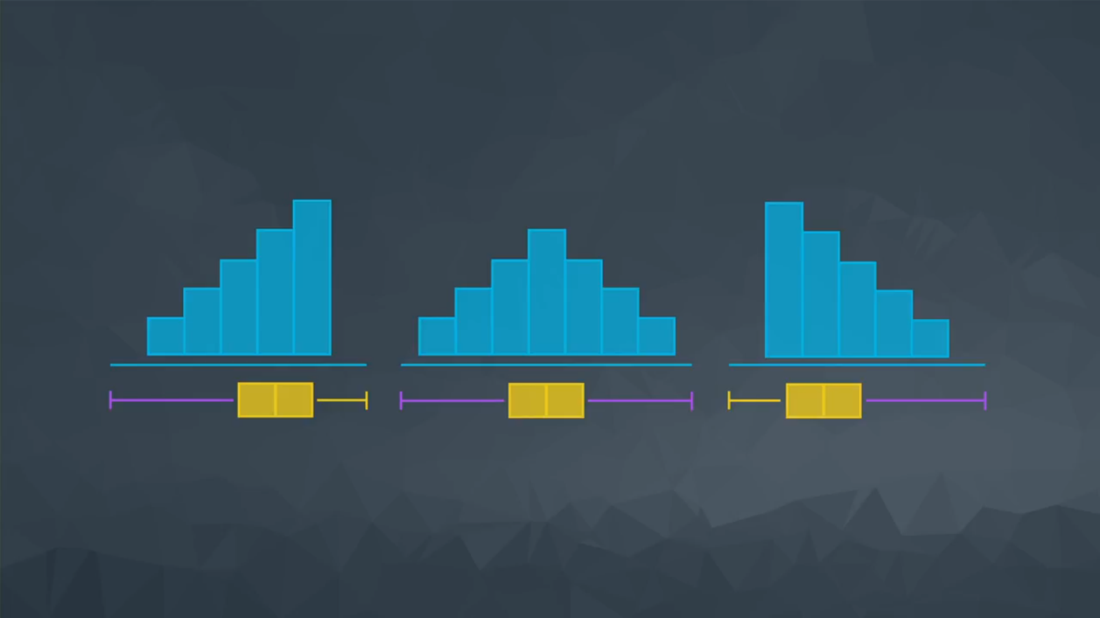

Right skewed, symmetric, and left skewed with his box blot shape

Depending on the shape associated with our dataset, certain measures of center or spread may be better for summarizing our dataset.

When we have data that follows a **normal** distribution, we can completely understand our dataset using the mean and standard deviation.

However, if our dataset is **skewed**, the 5 number summary (and measures of center associated with it) might be better to summarize our dataset.

**Outliers**

We learned that outliers have a larger influence on measures like the mean than on measures like the median. We learned that we should work with outliers on a situation-by-situation basis. Common techniques include:

**1.** At least note they exist and the impact on summary statistics.

**2.** If typo - remove or fix

**3.** Understand why they exist, and the impact on questions we are trying to answer about our data.

**4.** Reporting the 5 number summary values is often a better indication than measures like the mean and standard deviation when we have outliers.

**5.** Be careful in reporting. Know how to ask the right questions.

**Histograms and Box Plots**

We also looked at histograms and box plots to visualize our quantitative data. Identifying outliers and the shape associated with the distribution of our data are easier when using a visual as opposed to using summary statistics.

# Descriptive vs. Inferential Statistics

In this section, we learned about how **Inferential Statistics** differs from **Descriptive Statistics**.

## Descriptive Statistics

Descriptive statistics **is about describing our collected data** using the measures discussed throughout this lesson: measures of center, measures of spread, the shape of our distribution, and outliers. We can also use plots of our data to gain a better understanding.

## Inferential Statistics

Inferential Statistics **is about using our collected data to draw conclusions to a larger population**. Performing inferential statistics well requires that we take a sample that accurately represents our population of interest.

A common way to collect data is via a survey. However, surveys may be extremely biased depending on the types of questions that are asked, and the way the questions are asked. This is a topic you should think about when tackling the first project.

We looked at specific examples that allowed us to identify the

1. **Population** - our entire group of interest.
2. **Parameter** - numeric summary about a population
3. **Sample** - a subset of the population
4. **Statistic** - numeric summary about a sample